## **Black Rock City Honoraria**

2020 Full Proposal Preview

## **Intro**

Thank you for wanting to share your creativity in Black Rock City!

You’ll see that some of the questions in this form have been pre-filled with the information you submitted with your Letter of Intent (LOI). Please feel free to leave them as-is, or edit, replace, or expand on each of them as needed. In some cases, the length limit is higher on this form than it was on the LOI to give you more space to explain your project. Note that these character limits are maximum and not recommended lengths; in many cases, a response that is substantially shorter than the maximum will sufficiently respond to the question.

We understand that your project may have evolved since the LOI, but the general concept of the project must be the same as what was initially proposed.

The deadline to submit a full proposal is **January 22, 2020 at 5pm Pacific Time**. Late proposals will not be accepted. We will notify applicants by early March 2020.

Thank you!

## 

## 

## **Summary *Asterisk Indicates Response Required**

#### 

#### 

#### **Art Installation Title\***

#### Revolutionary Labyrinth

#### **Artist Group, Collective or Organization Name** If applicable.Up to 255 characters of text

Nostalgia Purgatory

#### **Artist or Collective Bio\***

Up to 500 characters of text.

I began “Nostalgia Purgatory” in June 2018 for making collaborative immersive theater and narrative-evoking environments. My evolving team and I create interactive spaces for audiences to explore fiction, history, and surrealist scenes in full sensory settings. Themes of “choose your own adventure” are present in my work, rewarding participants for their curiosity and inviting people to dig deep in the setting presented to them in order to discover an embedded story or sensory affect.

#### **Project Website**

###### If you already have a website for this project, share the link here.​

###### Please use a valid URL format, including "http://" and use all lowercase letters.

#### **Artist Group, Collective or Organization Website**

#### (can put NostalgiaPurgatory.com but need to edit website to reflect current project. Last priority)

## 

## 

## 

## 

## **Project Narrative**

#### **Project Summary\*** Up to 300 characters of text

###### 

###### A labyrinthine grid of revolving rooms that link together unique works of installation art. Manipulatable pathways will entice the participant to come back many times to try new combinations of revolutions, leading them to find a microcosmic multiverse of art that has yet to be seen.

###### 

#### **Physical Description\*** Up to 1000 characters of text

###### Share a physical description of the proposed installation. What will the project look like? What will its visual impact be?

###### If you are incorporating fire into your artwork, detailed questions will be asked later in this application.

The labyrinth is a grid of 13 cylindrical alcoves housing unique works of multisensory installation art, each made by a different artist based on the basic prompts of “sensory manipulation”, “nostalgia”, and “multiverse.” Each revolving door offers 3 options (left, right, center) to adjacent artworks. Perimeter doors of the structure exit to open playa. When the participant is inside one space, they will manually revolve the walls of the cylindrical installation either left or right by way of interior handles to access adjacent alcoves. This creates a unique pathway of combinations. Doors that are adjacent to each other may interact with one another, or isolate certain senses to provide the viewer with an indulgent and interactive moment. When occasionally faced with the backside of a cylinder, the participant sees a surface bathed in colored light, illuminating the spaces between cylinders, and a railing encircling each room which is designed to function as an external handle.

#### **Interactivity\*** Up to 1000 characters of text

###### Interactivity is an essential aspect of the art of Burning Man. Describe how your concept is interactive and participatory. How will the citizens of Black Rock City interact with your art?

###### Please keep in mind that citizens of Black Rock City have minds of their own and may not interact with your art in the ways you expect.

Revolutionary Labyrinth is a “choose your own adventure” maze, with no wrong pathways through it. Wholly about interacting with the structure of the maze itself, manually grasping and moving the installation artwork around oneself is necessary in order to reveal the next thresholds to enter. The manufacture and interactivity of the turning cylinders are much like the design of revolving darkroom doors, but more spacious. The themes offered to each installation artist as a basic prompt are “sensory manipulation”, “nostalgia”, and “multiverse”. Many of the installations contained within involve triggered effects and manipulate the senses by way of light array art, illusions and puzzles, smell, touch/tactility, and sound related to the environment or concept the installation is trying to convey. Audio/visual musicians, set designers, sculptors, escape room builders, and textile artists are among those filling out a provided template and interested in contributing their vision.

#### **What is the philosophy of your piece?\*** Up to 1000 characters of text

###### What are you hoping to express with the manifestation of your installation? What does the art mean to you? What do you hope to communicate to participants?

Pathways through life are made by finding oneself in a particular environment, and choosing one of the doors that have opened to you. The labyrinth echoes living experience with revolving microcosms of built worlds assembled into a maze. One must grasp and move the physical manifestation of a concept around themselves, immersing their visual periphery in the surrounding installation. Sensory manipulation has the power to tap into our associated memories in an all-encompassing transformative experience. Memory triggering “affects” may be the color indigo, the sound of crickets, or the smell of freshly cut grass. Installations in this project evoke alternate universes or timelines through sculptural intervention, manifestations of remembered moments or playful effects utilizing the physical rotation of the labyrinth. The archetypical version of a maze or labyrinth is not what we are trying to achieve here. It is an anti-maze, with no solution, and no empty dead ends.

## **Safety and Engineering**

#### 

#### 

#### **Safety and engineering of the installation are the artist's responsibility. What safety procedures or engineering strategies do you expect to have in place when it is installed on-playa?​\*** Up to 1500 characters of text

###### Note that if your proposed structure involves significant architecture such as public platforms or large kinetic mechanisms, you will be required to provide engineering evaluations verifying the safety of the structure and the forces applied to it from people and nature.

###### If applicable to your project, we may request these documents during the grant review cycle, and they must be provided before any payment is issued.

###### For further information please read about [Building Safe Structures](http://burningman.org/event/art-performance/playa-art/building-safe-structures/).

The build team includes architects, mechanical, structural, and electrical engineers with years of experience on bringing art to the playa. We are familiar with the many kinds of weather related and participant related challenges present at the event. Our art is a labyrinth of 13 revolving rooms built similarly to darkroom doors. The floors are stationary with a track guiding the floating cylindrical walls. Friction brakes limit rotational speed. Welded steel support frames are designed to resist winds on playa, with footings lag bolted 14” into the ground. Each cylinder will be completely built and tested with artwork installed before shipment. At least 5 cylinders will be tested at a regional burn in July to endure play from curious participants. We will observe how people navigate through the maze, how it withstands heavy use, and make changes as needed. To address concerns about egress, a glowing diagram of the labyrinth will be stencilled onto each platform indicating which cylinder the viewer is standing in, with an arrow pointing toward the perimeter. Cylinders will be arranged for participants to quickly exit from any point in the installation. No footholds exist and “no climbing” signs will be posted. Their free rotation will also make them difficult to climb. Although our project is under 9’tall, mechanical drawings and calculations including structure self-weight and people loads will be produced for review by former honorarium grant recipients Blake Courtney, Ange Sarno, Jason Turgeon, and Blake Courter.

// had to edit it down a few characters at last minute //

The build team includes architects, mechanical, structural, and electrical engineers with years of experience on bringing art to the playa. We are familiar with the many kinds of weather related and participant related challenges present at the event. Our art is a labyrinth of 13 revolving rooms built similarly to darkroom doors. The floors are stationary with a track guiding the floating cylindrical walls. Friction brakes limit rotational speed. Welded steel support frames are designed to resist winds on playa, with footings lag bolted 14” into the ground. Each cylinder will be built and tested with artwork installed before shipment. At least 5 cylinders will be tested at a regional burn in July to endure play from curious participants. We will observe how people navigate through the maze, how it withstands heavy use, and make changes as needed. To address concerns about egress, a glowing diagram of the labyrinth will be in each platform indicating which cylinder the viewer is standing in. Cylinders will be arranged for participants to quickly exit from any point in the installation. No footholds exist and “no climbing” signs will be posted. Their free rotation will also make them difficult to climb. Although our project is under 9’tall, mechanical drawings and calculations including structure self-weight and people loads will be produced for review by former honorarium grant recipients Blake Courtney, Ange Sarno, Jason Turgeon, and Blake Courter.

THANK YOU BOTH

You’re welcome :) You are now under 1250 characters if you want to add something about spacing the cylinders to allow egress from any point.

Thanks! I think this is good now.

Headed to lunch. Good luck!

### **Leave No Trace Plan\***

#### Up to 2000 characters of text

#### *Leaving No Trace is one of the* [*10 Principles*](https://burningman.org/culture/philosophical-center/10-principles/) *and we take it very seriously. A performance deposit will be withheld from your grant until after the event, and one of the steps you must complete in order to receive your deposit is to Leave No Trace. If your site is not clean, and/or you don’t complete the check-in and check-out process on playa, your deposit will be withheld.*

#### *Describe in detail your Leave No Trace plan. This should include your cleanup strategies during the installation, through the event, and post-event/deinstallation. If your project includes inherently MOOP-y materials (fabric, branches, ribbons, etc.) please address this in your plan.*

#### *Please read* [*Leave No Trace for Artists*](https://burningman.org/event/art-performance/playa-art/leave-no-trace-for-artists/) *before writing your LNT plan.*

Lead Artist Jaden Andrea has a degree concentration in Nature-Culture Sustainability, and in 2018 she stayed post-event for playa resto crew and understands the important impact the smallest trace left behind will have on the future of the desert and the future of the event. Because of resto experience, the crew will be effectively trained in moop discovery and disposal! Leave No Trace is a matter seriously taken by the assembled crew. We will have twice daily Moop sweeps and collect matter left behind by participants for removal at the end of the event. Few aspects of the Labyrinth cylinders are wooden and all will be pre-cut and painted, steel frames welded, stress tested, and flat packed for delivery and removal from the playa. Contributing artists are being given explicit instructions to securely fasten all components of their installations to the cylindrical walls and may not use any loose, particulate, or delicate material for decoration. No inappropriately moopy material will enter the shipping container from BOS to BRC. We will employ the use of landscaping and magnetic rakes. We are packing in and packing out this art project and not planning on burning any aspect of it. We are going to break down each cylinder into nesting quadrants and take it from the install site in a truck back to the Boston containers.

#### **What build materials will you use to construct your piece?​\*** Up to 500 characters of text

###### Examples: wood, stone, metal, paper, 4x4 steel box tube with ¼" wall thickness, 6x6 fir beams, LVL beams, etc.

### Rolled steel cylindrical frames, Aluminum sheeting, ¾ inch Plywood sheets, LED lightstrips, various interior decorative elements.

### **Physical Dimensions of Your Piece**

###### We use the dimensions provided for evaluating many aspects of your work.

###### Most artwork can be dimensioned either as a **cube** or a **cylinder**.

###### A **cube form** has a:

###### Height (ground level to highest point)

###### Width (left to right)

###### Length/Depth (front to back)

###### If the artwork is **cylindrical, conical, elliptical, or spherical** in shape it has a:

###### Height (ground level to highest point)

###### Diameter (greatest distance across the ground level)

#### **Which option best describes the shape of your artwork?\***

###### **Cube**

###### Cylinder/Cone/Sphere

#### **Height\***

###### Provide all measurements in feet. Round up to the nearest whole foot.

9 ft

#### **Width (left to right, for cube shapes)\**[1]***

###### Provide all measurements in feet. Round up to the nearest whole foot.

22ft (width and length)

#### **Length or Depth (front to back, for cube shapes)\**[2]***

###### Provide all measurements in feet. Round up to the nearest whole foot.

36ft (diagonal / at widest measurement)

###### **Diameter (for cone, cylinder, or sphere shapes)*[3]**

###### Provide all measurements in feet. Round up to the nearest whole foot.

### 

### 

### **Lighting Plan**

#### **How will you illuminate your art installation?\*** Up to 1500 characters of text

###### Black Rock City can be a very dark environment; your art installation must be sufficiently illuminated at night, not only during the event but also during construction. This includes any rebar, guy wires, and any other part of the installation that may cause someone to be seriously injured. Describe how your project will be made visible at night to ensure participants’ safety.

The first lights which go up will be work lighting during construction. Secondary running lights will be present before the structure is completely built, and 12V batteries provide backup power for these lights even if the generator is off. The upper half of the external walls of the cylinders will be illuminated using multicolored LEDs encircling the cylinder walls from above. The cylinders will also be uplit from below using white LED “neon” tubes encircling the static platforms. Each cylinder will be downlit with a different color combination. This is so that the night-time appearance of the labyrinth from a distance will appear to be swaths of color that shift at intervals organically, as persons rotate the cylinders (and thus the colors) as they navigate their way through the labyrinth. A commercial slip ring assembly at the pivoting top of each cylinder safely supplies low voltage (12V) power to illuminate the interior and exterior of every cylinder. A 3kW generator will provide primary power at night. Backup and daytime power will be provided by 12V deep cycle marine batteries, with an option to charge them using solar panels. Lighting and any other powered effects within each cylinder will be designed by the installation artists and will vary in type, but all elements will be fixed to the walls and all lighting will be outdoor grade LED.

#### **Are there sound elements intrinsic to your piece?\***

###### Yes

###### No

#### 

#### **Please describe your sound elements. *[4]** Up to 800 characters of text

###### What are they and what is their impact on participants or other surrounding art installations? Specifically, tell us from how far away your sound will be heard - just inside your installation (ambient), 10 feet away, etc. Please note that we do not fund or place performances, bands, DJs, or amplified sound in art installations.

Sound elements of the Revolutionary Labyrinth are not going to be audible from outside the immediate area of the work. As a multi-sensory project sound is intrinsic in that it is present in some-but-not-all of the installations. Some contributing artists will utilize small speakers as part of their installation artwork for sound that contributes atmospherically to the setting or concept within. Other installation artists may not desire sound at all in their works, and the sound from others will be soft enough to not carry far beyond the source. One installation artist is designing for the idea of turning the centermost cylinder into a cylindrical music box, adding pegs to the cylindrical walls and fixing a metal musical comb to the supports in order to strike notes.

#### 

#### **Do you envision your artwork potentially being placed in a setting outside Black Rock City after the Burning Man event?​\***

###### **Yes**

###### No

#### **Please describe any changes or modifications you would need to make to the piece to make its placement off-playa possible after the event.​*[5]** Up to 800 characters of text

###### 

No modifications will need to be made to the design of the labyrinth in order for it to have another life after Burning Man. Flushing the bearings and cleaning the installations and track of playa dust should be enough to install a system of revolving alcoves, arranged in any order, at a location elsewhere. Each cylinder is self suspending, so it may be that after Burning Man they will split up and be installed as individual installation spaces (1 cylinder), smaller grid systems (5 cylinders), or that we will scale up and create more cylinders for an even larger labyrinth (25 cylinders). The pattern of our labyrinth grid follows the mathematical pattern of centered square numbers.

## 

## 

#### **Total Budget Amount\***

###### Please list the amount of your project’s total budget. This should match the total number on your budget spreadsheet.

###### 

###### If you are interested in offering scalable options, you may suggest multiple tiers for funding, for example, a large, medium, and small version of your project at corresponding budget amounts. If proposing multiple options, please use Tier 1 as your highest-dollar option, Tier 2 as middle and Tier 3 as lowest.

###### 

###### The pre-filled number is what you submitted with your LOI but you may change it slightly here.

###### **Please enter a whole number (not a range) in US Dollars.**

###### Total Budget Tier 1 (highest amount): $ 24,490

###### Total Budget Tier 2:

###### Total Budget Tier 3:

#### 

#### **What is the amount of funding you are requesting from Burning Man for the project described in this application?​\***

###### If you offered scalable options in the previous question, please include corresponding funding requests and tiers here. Note that, for the most part, Burning Man only partially funds honorarium projects, so we strongly recommend that your Funding Request not be 100% of your total budget.

###### 

###### The pre-filled number is what you submitted with your LOI but you may change it slightly here.

###### **Please enter a whole number (not a range) in US Dollars.**

###### Funding Request Tier 1 (highest amount): $14,760

###### Funding Request Tier 2: $

###### Funding Request Tier 3: $

#### **Budget Range Details\*** Up to 500 characters of text

#### If you have entered more than one tier for your budget and funding request, please describe the differences between each tier.

#### **Preferred Funding Tier\***

#### *If you provided budget tiers, which tier would you most prefer we fund?*

###### Tier 1

###### Tier 2

###### Tier 3

#### **Budget Spreadsheet\***

**Fundraising Plan\***Up to 1000 characters of text

###### Burning Man typically partially funds art projects. What are your plans and strategies for raising the additional necessary funds?

For raising the rest of the funds, a crowdfunding platform will be utilized to describe in detail the scope and intention of the project. Fundraising events will be hosted during the spring and summer preceding the event in the New England/Boston community, and a small (5 cylinder) scale version of this concept will be submitted for art grant consideration from Firefly arts collective, the New England regional burn in Vermont.

###### **Start Build Date\***

###### If awarded a grant, when would you begin your build (before arriving on playa)?

###### Please enter the date in this format: MM/DD/YYYY

03/01/20

#### **Build Location\*** Up to 300 characters of text

###### If awarded a grant, where would you execute most of your build (before arriving on playa)?

*Please list the city, state and country of the location, not just the name of the venue.*

Boston, MA, USA

Artisan’s Asylum

#### **Build Crew\***

###### Have you already identified adequate crew to build, install, and clean up your art installation?

###### **Yes**

###### Not yet

#### 

#### 

#### 

#### 

#### 

#### 

#### 

#### 

#### 

#### **Support Crew\*** Up to 1000 characters of text

###### Whether or not you have identified your crew, describe all roles and skills you require to make your art installation a success. Let us know which roles have been filled.

###### 

###### Also, please provide a numerical estimate of your core crew (a range is acceptable).

###### If you have identified some or all of your support crew, please list crew members’ names and the roles they will fill.

We understand that you will likely not allot us tickets for both the build crew and one for each installation artist. We would like to ask negotiably for 15 tickets .

Note: some of these are hopefuls or people I’ve talked to but **not** a list of commitments… nonetheless wanted to submit names!

Very necessary for build week:

Lead Artist, Jaden Andrea (Blunderwood Portable)

Assistant Lead, TBD

Electrical Lead, Carl Gruesz (Man Base LED lighting, 2005 + 2007, Cosmic Praise)

Electrical Support, Anthony Niccolaidas (Blunderwood Portable, RayActivation)

Architectural Designer, Ange Sarno (Windchest)

Architectural Support, Seth Avecilla

Structural Engineer, Blake Courter (Pemrose) or Terry DaCosta (Windchest)

Lead Welder/Fabricator, Blake Courtney (Pemrose Triangle)

Assistant W/F, Morgan Kyle White (Golden Guy)

3-5 Installation Artists, (Installation Artist x13 - Sara Dunn, Aisling O’Toole, Rebecca Kopycinski, Michael Dewberry, Kellian & Brian Pletcher, Carlos Torres, Mian Wei, subject to change, but committed interest)

2-3 Installation Coordinators managing 2-3 installations by artists unable to attend Burning Man, TBD

Position/Name/(relevant projects they’ve done at burning man)

#### **Please upload your Project Timeline.\***

## 

## **Fire Plan**

#### **Are there any fire, flame effects, and/or pyrotechnics involved in your artwork?​\***

###### Yes

###### No

#### **Do you plan on including Open Fire in your art installation?​*[6]**

###### Open Fire is defined as non-pressurized flame, including setting fire to an art installation, incorporating burn barrels, braziers, torches, assemblies of candles, and/or other simple uses of fire.

###### Yes

###### No

#### **Open Fire Plan*[7]** Up to 1000 characters of text

###### Please describe briefly how you plan to incorporate Open Fire in your art installation.

###### 

###### Explain whether it is a contained flame like a candle, burn barrel, etc. or if you will be setting your artwork on fire. Note: The logistics involved in your artwork are greatly affected by the decision to burn the project. The Fire Art Safety Team (FAST) will contact you later in the process to go over your use of fire. Receiving an honorarium does not guarantee approval for burning the project as all burn plans will be reviewed separately.

#### **Do you plan on including Flame Effects in your art installation?​*[8]**

###### Flame Effect is defined as “The combustion of solids, liquids, or gases to produce thermal, physical, visual, or audible phenomena before an audience.” This includes all flames that are automated, switched, pressurized or having any other action than simply being lit on fire, as well as projects using propane or other liquid or gaseous fuels.

###### Yes

###### No

#### **Flame Effects Schematics/ Details*[9]** Up to 1000 characters of text

###### If your artwork utilizes flame effects, please describe how you intend to use them in your project.

###### 

###### Note: At a later time, the Fire Art Safety Team (FAST) will need to know specifics such as the components of your system and how they relate to one another, fuel storage vessels, fuel delivery mechanisms, manual or remotely controlled valves, expansion or accumulator tanks, forced air blowers, manifolds, ignition systems, details of the flame head(s) (e.g., do they include venturis, etc.), and your fire-control system.

###### 

###### Please be aware that receiving an honorarium does not guarantee approval for flame effects, which will be reviewed separately.

#### **Do you plan to incorporate Pyrotechnics in your art installation?​*[10]**

###### Pyrotechnics refers to the art, craft and science of fireworks, which includes any explosives or projectiles.

###### Note: All pyrotechnic material/devices used in any art installation or performance must consist of consumer [1.4G Class C, UN0336] fireworks or less. Absolutely NO display [1.3G Class B, UN0335] fireworks (professional fireworks) or higher will be permitted at any art installation or performance.

###### Yes

###### No

#### **Pyrotechnic Details*[11]** Up to 1000 characters of text

###### Please briefly describe how you plan to incorporate pyrotechnics/special effects material into your art installation. \

###### 

###### At a later time, the Fire Art Safety Team (FAST) will contact you about specifics including materials to be used and how they will be used. Pyrotechnics require many additional hours of perimeter for their safe setup and hours of playa restoration the following day.

###### 

###### Please also add details of how you plan to address these additional crew needs.

## 

## 

## **Art Image Upload**

### You must submit two to **five** images of your concept (.jpg or other image file - PDF is not acceptable). They may be drawings, photos, diagrams, CAD designs, or any other method of visual explanation. You may want to show the full project, close-ups, the interior, the exterior. They can be as simple or complex as you need it to be; the goal is to help the grant committee fully understand your proposed project as completely as possible.

Please don’t upload a collage with multiple images as one of your images; each image should be its own upload.

### 

### If the images from your LOI are still the best representation of your project, upload them again here.

#### **Primary Image\***

###### This is the image we will see most frequently when reviewing your proposal, so select your best image & upload it here.

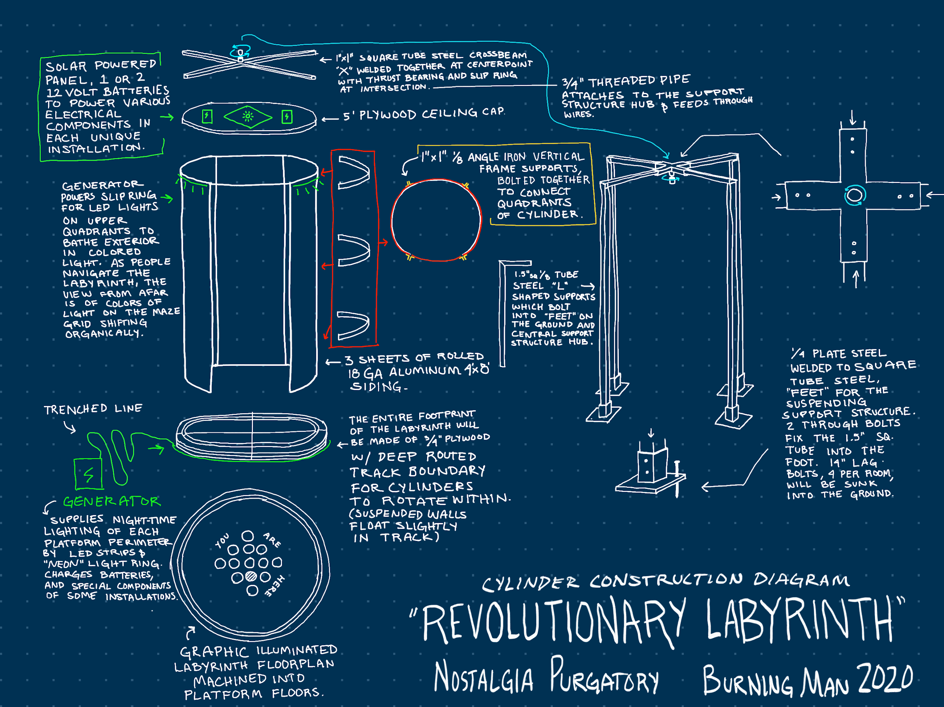

###### 

###### Image Requirements

###### Maximum file size: 10MB

###### Accepted file types: .jpg .gif .jpeg .pjpeg .png (not pdf)

###### The file extension (i.e., .jpg) must be included.

###### You must use a computer (not a phone or tablet) to upload your images.

###### You must have JavaScript enabled. If you need help with that, see: [enable-javascript.com](http://www.enable-javascript.com/).

#### **Second Image\***

###### Upload a second image, following the same requirements.

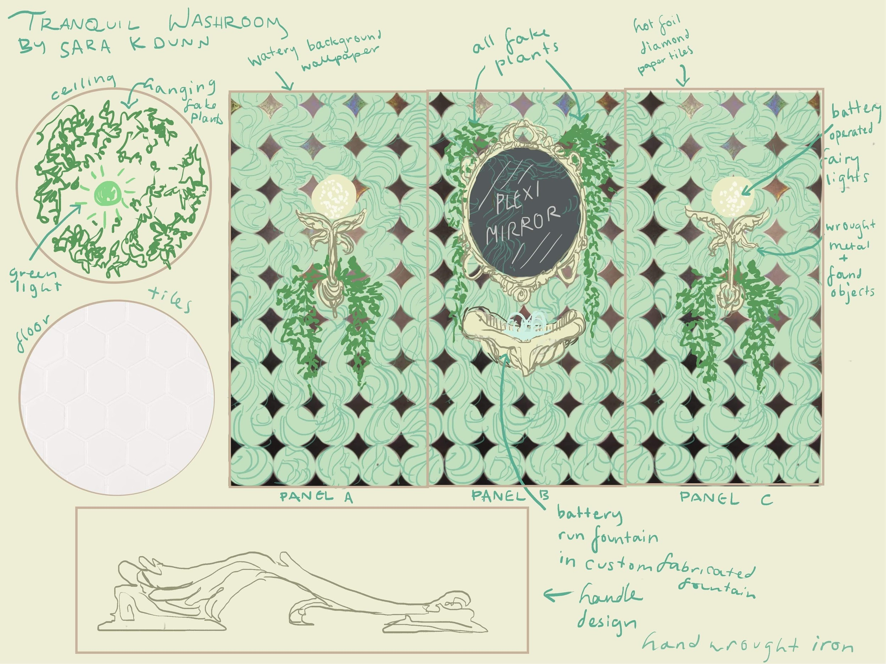

#### **Additional Image(s)**

###### You may upload up to three additional images here, following the same requirements.

SEE GOOGLE DRIVE

#### **Video**

###### If you would like to include a video or other media available online (e.g. on YouTube or Vimeo), you may share the URL with us here.

###### 

###### Please use a valid URL format, including "http://" or “https://”.

<https://www.youtube.com/watch?v=R0FOq6U-jEo>

#### **Media Info** Up to 500 characters of text

###### You may use this space to describe or explain the images you are submitting if they require additional notes.

#### 

#### **Is there anything else you think we should know?** Up to 500 characters of text

Some installation artists may not be able to attend the build week or festival, but have a strong concept and desire to contribute to the labyrinth. For this reason there is a need for crew members who are also “installation coordinators”. They will communicate directly with the installation artists before the event and oversee the installation of multiple works on site.

#### **Physical Maquette Submission**

#### 

#### **Will you be submitting a maquette or small model of your proposed artwork?\***

###### Yes

###### No

## **Save and Continue**

### 

### **Your application will be submitted when you click on the SUBMIT button below.**

### 

### If you do not want to submit your application at this time, you can save your work and return at another time to finish it. To do so, **click on the Save and Continue bar at the top of this page.**

### 

### Your work will be saved, and an email will be sent to you with a link.

### • From: Burning Man Arts

### • Subject: Save and Continue Link for BRC Honoraria Proposal

1. This question is only required if the shape of your artwork is a “Cube.”
2. This question is only required if the shape of your artwork is a “Cube.”
3. This question is only required if the shape of your artwork is a “Cylinder, Cone or Sphere.”
4. This question is only required if you selected “Yes” in the previous question.
5. This question is only required if you selected “Yes” in the previous question.
6. This question is only required if you selected “Yes” in the previous question.
7. This question is only required if you selected “Yes” in the previous question.
8. This question is only required if you selected yes to the first fire question.
9. This question is only required if you selected “Yes” in the previous question.
10. This question is only required if you selected yes to the first fire question.
11. This question is only required if you selected “Yes” in the previous question.